JIBAS (The International Journal of Islamic Business, Administration and Social Sciences) (Quarterly) Trilingual (Arabic, English, Urdu) ISSN: APPLIED FOR (P) & (E)  Home Page: http://jibas.org  Approved by HEC in Y Category  Indexing: IRI (AIOU), Australian Islamic Library, Euro Pub.  PUBLISHER HABIBIA RESEARCH ACADEMY  Project of JAMIA HABIBIA INTERNATIONAL,  Reg. No: KAR No. 2287 Societies Registration Act XXI of 1860 Govt. of Sindh, Pakistan.  Website: www.habibia.edu.pk,  This work is licensed under a Creative Commons Attribution 4.0 International License.   | 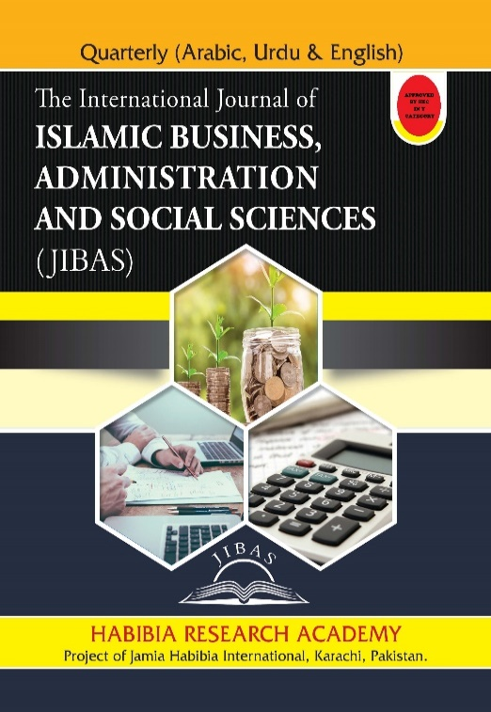
TOPIC:
AN INVESTIGATIVE STUDY OF THE DISTORTION OF THE GEOGRAPHY OF THE HEBREW BIBLE TO CONCEAL THE PRESENCE OF ABRAHAM AND HIS DESCENDANTS IN THE ARABIAN PENINSULA
AUTHORS:
- Noor Akram, Research Scholar, Karachi University, Lecturer Govt Boys Degree College Jhuddo, Email ID: Noordawa1430@gmail.com Orcid ID: https://orcid.org/0000-0003-2816-0850
How to Cite: Akram, Noor. 2023. “ AN INVESTIGATIVE STUDY OF THE DISTORTION OF THE GEOGRAPHY OF THE HEBREW BIBLE TO CONCEAL THE PRESENCE OF ABRAHAM AND HIS DESCENDANTS IN THE ARABIAN PENINSULA”. International Journal of Islamic Business, Administration and Social Sciences (JIBAS) 3 (3):01-24.  URL: https://jibas.org/index.php/jibas/article/view/110  Vol. 3, No.3 || July –September 2023 || P. 01-24  Published online: 2023-09-30 |  | QR. Code  

AN INVESTIGATIVE STUDY OF THE DISTORTION OF THE GEOGRAPHY OF THE HEBREW BIBLE TO CONCEAL THE PRESENCE OF ABRAHAM AND HIS DESCENDANTS IN THE ARABIAN PENINSULA
Noor Akram
ABSTRACT:
The Jewish people claim that the land promised to Ibrahim's descendants was only for the children of Israel and that Hazrat Ibrahim and his descendants never came to the Arabian Peninsula. This claim is based on bragging, selfishness, and lies. The main characters of distortion are Levites and Jeroboam. The reasons for blaming them have been mentioned in this article in detail. Their claims neither logically nor historically meet the truth. The Torah admits that Hazrat Ismail was circumcised, and the Arabs used to circumcise, which was not practiced in any other nation except Arabs and Jews. Arabs also introduced themselves as descendants of Hazrat Ismail, and historically, they occupied Makkah and Zamzam as heirs. The Qur'an, on the other hand, does not mention the names of many regions or figures in many stories, possibly to prevent Ahle Kitab from spreading propaganda against the accuracy of the Holy Qur'an. The distortion in maps, names of cities, and races had allowed them to hide the reality. I have managed to solve the riddle of geographical changes by using archeological information of those areas. Reality shows that not only Ibrahim, Ismael, Isaac, and their early descendants but also Bani Israel themselves spent most period in Arabia.
KEYWORDS: Torah, Distortion, Levites, Jeroboam, Hazrat Ibrahim, Hijaz, Hazrat Ismail.
INTRODUCTION:
Jews claim that the land that Allah SWT had promised to Ibrahim's descendants, was only for the children of Israel, and the land that Allah SWT had given, was of Israel. Their further claim is "Neither Hazrat Ibrahim nor any of his descendants ever came to Arabian Peninsula, nor, are the Arabs descendants of Hazrat Ibrahim."
Their claim that Ibrahim's descendants mean only Isaac and then only Jacob from Isaac is based completely on bragging, selfishness, and lies. Otherwise, the question arises that when God meant by this promise only the children of Israel why would have He mentioned the descendants of Ibrahim? Instead, he should have told the children of Israel from your descendants. Furthermore, there was no need to promise to Ibrahim, this promise should have been only with Jacob.
The second part of their claim that Ibrahim did not come to Saudi Arabia, nor Ismail and Hajra came to Saudi Arabia, nor are the Arabs the descendants of Ibrahim, is also not more than the boosting, as Torah itself admits that Hazrat Ismail was circumcised. And Allah SWT had made a covenant with Hazrat Ibrahim that your descendants will be circumcised. And the Arabs used to circumcise. On the other hand, it was not practiced in any other nation than Arabs and Jews. When circumcision was made by Allah SWT as a sign of being the descendant of Hazrat Ibrahim, how can someone deny the fact?
Furthermore, Arab people used to call themselves followers of the Ibrahimic religion. If Ibrahim did not come to Hijaz, how did the Arabs find out about Ibrahim? In the third place, the Arabs used to introduce themselves as the descendants of Hazrat Ismail, and historically, being the descendants of Hazrat Ismail, they occupied Makkah and Zamzam as heirs. How can one deny all these things that were passed down from generation to generation among the people even before Islam and even when they were not the learned ones?
On the contrary, when we study the Qur'an, we feel that the Holy Quran does not mention the names of most regions or figures in many stories. For example, the mention of Zabeeh does not explain with clear words who the Zabeeh was. Or in which city did Ibrahim live? Or where did he go with his son for sacrifice? On the other hand, the Qur'an mentions many of the important stories which were described in the Hebrew Bible. By revealing all the details of almost all the important incidents of the book but keeping silent about the area or figure, the Qur'an already has given his decision indicating the distorted place. The reason behind not mentioning the truth, apparently was to stop Ahle Kitab, from spreading propaganda against the accuracy of the Holy Qur'an. The other reason behind keeping silent may be the Qur'anic rule and method of arguing with Ahle Kitab, which is to only mention the agreed things and not discuss differences.
I started studying the Hebrew bible in 2010 and spent fourteen years in this study. Along with this, other books of the Jewish religion, especially the Mishnah, were also in my study. In the Torah and the Bible, there had been a large-scale distortion also, But mostly there are not big distortions to hide reality. On the contrary, they just have changed the maps, names of the cities, and some races. Although they have tried their best to change the entire geography, in this cycle they have filled the entire book with contradictions.
Even today there are many signs in the book for the discerning to understand the truth. In this study, I realized that while this book narrates other stories and anecdotes, it also mentions the Prophet (peace and blessings of Allah SWT be upon him) and his ancestors. As well as it is describing the attributes of the Prophet ﷺ and his Ummah, but this whole book is wrapped up in a puzzle. If one finds that riddle, it will not be difficult to identify the Holy Prophet from the Holy Book. Finally, I managed to solve this puzzle. And the puzzle was the change in geography, name of the cities, and concealing mention of certain races.

Claims of the Jews

Promise to Ibrahim:
The first part of the claim of the Jews found in their literature is that Allah SWT had promised Ibrahim that I will give all this land of Canaan to your generation, its east, west, north, and south are all yours and I will give your generation so much. I will increase like the particles of the earth. For this, reference is made to the verses mentioned in Genesis chapter 13:
"And יהוה said to Abram when Lot had parted from him, "Lift your eyes and look wherever you are, north and south, east and west, for I give all the land that you see to you and your offspring forever. I will make your offspring as the dust of the earth, so that if one can count the dust of the earth, then your offspring too can be counted "(“Genesis” n.d.)

Generation of Hazrat Isaac was meant:
But on the other hand, the Jews claim that the "offspring" in this promise refers only to the generation of Hazrat Isaac. While the sons of Ismail or the other sons of Hazrat Ibrahim are also mentioned in the Torah, they are not included in it. The promise that Allah SWT made to Ibrahim that I will increase your descendants or give you the Promised Land, etc., was not for any other son, but only for the descendants of Isaac. In the Book of Genesis, after the birth of Hazrat Ishmael, it is mentioned in chapter number 17 in response to the prayer of Hazrat Ibrahim.
“But I will keep my covenant with Isaac, whom Sarah will bear to you at this time next year.” (“Genesis” n.d.)

Isaac was the slayed (Zabih)
In the Urdu translation that I have, they translated it as the only son using the word "اکلوتا" (موسیٰ, کتاب پیدائش ۔ عہدنامہ قدیم ۱۹۷۹)Then this same child Ishaq becomes the only one even though he has an elder brother and Zabih also becomes the only one. It is mentioned in the book of Genesis chapter number 22:
"They reached the place where Allah had told him. Abraham built an altar there. He laid the wood. He bound his son Isaac. He placed it on top of the wood on the altar. And Abraham picked up the knife to slay his son. Then a messenger of יהוה called to him from heaven: “Abraham! Abraham!” And he answered, “Here I am.” “Do not raise your hand against the boy, or do anything to him. For now, I know that you fear God since you have not withheld your son, your favored one, from Me” (“Genesis” n.d.)

Israel was chosen from descendants of Isaac
Then it is not only that Isaac was chosen and there is a covenant for all the descendants of Isaac. No way, their further claim is that there is also a promise for only the children of Israel among the descendants of Hazrat Isaac, and for this purpose, the writer takes the ball away from the eldest son and throws it directly into the cradle of the younger son. The promise to the children of Hazrat Ibrahim is not only that only one of Ibrahim's children includes Isaac, but beyond that, the first child of Isaac will also be deprived because he did not become the father of Bani Israel. The promise is given to the father of Israel. In Genesis chapter 25, Esau sells his birthright to his younger brother for a plate of curry.
"And Esau said to Jacob, "Give me some of this red stuff that I may go in, for I am hungry." Therefore his name was Edom. Jacob said, “First sell me your birthright.” And Esau said, “I am at the point of death, so of what use is my birthright to me?” But Jacob said, “Swear to me first.” So he swore to him, and sold his birthright to Jacob."
Then the writer adds a story of Jacob and his mother in the story, as if the mother and son deceived the father and the mother went with the younger son instead of the older son. The story is mentioned later on in the same chapter. (“Genesis” n.d.)

Boundaries of Promised Land
The next part of the claim is about the Holy Land and its boundaries. As for the matter, of which is the holy land and what its boundaries are, it's mentioned in the 10th chapter of Genesis:
(The [original] Canaanite territory extended from Sidon as far as Gerar, near Gaza, and as far as Sodom, Gomorrah, Admah, and Zeboiim, near Lasha.) (“Genesis” n.d.)
Along with this, their second claim is that since Canaan is only present-day Israel, Ibrahim did not go anywhere else from Canaan to Hijaz. And they did not build the house of Allah SWT and the place where they left Ishmael and Hajra is also inside Canaan and Canaan is the name of the country located in the north outside of Saudi Arabia. Therefore, the claim of Muslims that Ibrahim built the House of Allah SWT is also wrong, that the Holy Prophet is one of the descendants of Ismail is also wrong, and it is also wrong for the Prophet to migrate to Madinah or to come here.

Accusative answer for them
If we accept that the boundaries of Canaan are the same as described earlier and only this land was promised to Ibrahim by Allah SWT. So the first question is that Allah SWT gave only a small land to such a great prophet, and then the kings of that time used to give their servants pleasure. Second, the country that he promised to give was also given to Ibrahim's generation for only 400 years in the history of 4500 years. It is as if Allah SWT did not fulfill his promise. العیاذ باللہ

The formula for distorting the facts of the Torah
The formula used to distort the facts of the Torah consists of three points
Number 1. Hazrat Ismail and his descendants were covered.
Number 2. Hazrat Ishaq's eldest son and his descendants were covered up.
Number 3. The biggest deception was given by changing the geography of the story, which not only affected the religious people but even today's archaeologists are worried because it is not possible to completely reject the book that claims to contain a history of Characters

Importance of Correct Geography of Biblical Hebrew:
As far as the Ahle Kitab is the oldest historical book that a certain generation has been carrying around in their chests. It is not possible to completely reject its story. On contrary with the current geography, this book is a collection of such contradictions which have baffled even all archaeologists. Although the book is full of contradictions, I would like to present only two examples of this contradiction:
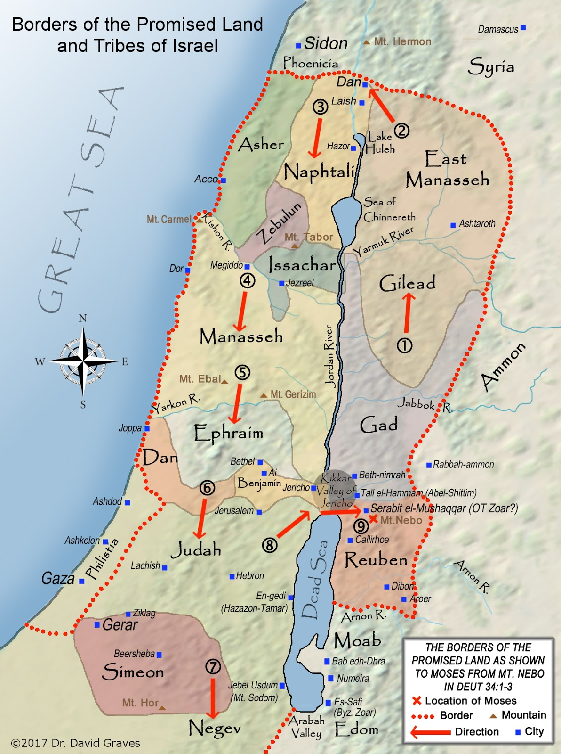
Map of promised land(Graves 2016)

Where did Hazrat Musa lead the children of Israel to cross the Red Sea?
In the thirteenth chapter of the book of Exodus:
"Now when Pharaoh let the people go, God did not lead them by way of the land of the Philistines, although it was nearer; for God said, “The people may have a change of heart when they see war, and return to Egypt.” (“Exodus 13” n.d.)
Which desert is meant here by the desert along the Red Sea? According to the distorters, the Sinai desert is meant here, and Musa (peace be upon him) took the Israelites to the Sinai desert and made them cross the Gulf of Aqaba. Although this is a violation of Allah SWT's order. Because the order was that do not take the road to Palestine and this is the road to Palestine. Now to strengthen this lie, they had to make Pharaoh's palace in the desert.
However, the fact is that Pharaoh's palace was on the banks of the Nile River, which is near the present-day Aswan province. Which has been discovered by archaeologists under the name of Buhin.
" Buhen was a large fortress located on the west bank of the Nile in Lower Nubia (ancient Waut).".(“Buhen: An Egyptian Fortress in Nubia” 2017)
If the children of Israel are fleeing from here, then the way to the Sinai desert is the way to Palestine and they will be caught straight in it. Now the desert through which they were ordered to go from here is certainly the desert of the Prophets whose location is in Britannica:
"Nubian Desert, desert in northeastern Sudan. It is separated from the Libyan desert to the west by the Nile River valley, while to the north is Egypt. To the east, the Red Sea; and to the south, again the Nile".(“Nubian Desert | Sahara, Sand Dunes, Erosion | Britannica” 2023)
If they had taken this desert, they must have entered Yemen from the current Eritrea or Djibouti near Yemen.
Another example is the following:

Instead of entering the country of Edom, walk by the sea.
In many places in the book, this article mentions that the Israelites walked along the shore of the Red Sea to avoid entering the land of Edom, for example in the number 21:
" They set out from Mount Hor by way of the Sea of Galilee to the land of Edom. But people became restless in the journey.", (“Tanakh | Sefaria” n.d.)
Surprisingly, in the map they described, Edom is shown to the southeast of the Promised Land, and the land of Moab, where the battle took place, is to the east. And to escape from Edom, according to this map, the Red Sea is nowhere to be found. Of course, according to the map we will tell you, to escape from Edom, they reached the shore of the Red Sea and then fought with the Moabites.
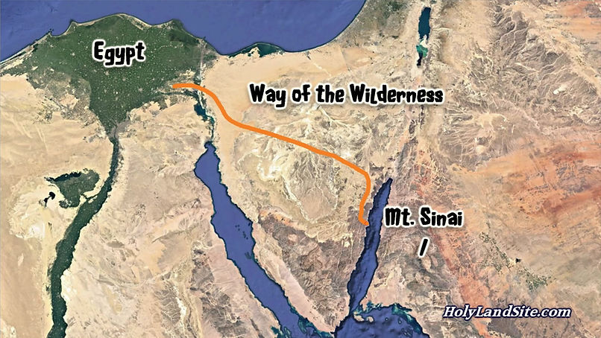
The map of fleeing from Egypt (“Exodus Route from Egypt, Red Sea Crossing Site, Mt. Sinai Location in Arabia | HolyLandSite.Com” n.d.)according to Ahle Kitab
A map of my research is given below
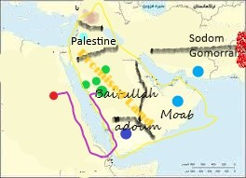

Who distorts the facts of the Torah?
The question arises, who can distort the Torah? And what is the benefit of it?
There are two persons responsible for the distortion in the Torah: Number 1: Leviticus. Number 2: Jeroboam and his descendants.

The entire Torah is not written by Musa and there are additions:
Even many conservative Jews admit that the present Torah was not written by Musa but was added to it. Apart from this, here I would like to refer to the blog of a Jewish writer. In which, a long blog, he proved by giving several passages of the Torah that it was not written by Musa. I will quote the sentence and conclusion presented by blogger Ezra Kohin.
"bn Ezra did not believe that the entire Torah was written by Musa, although he does not state his opinion openly. He mentions about a half dozen verses that indicate to him that they could not have been authored while Musa was alive".(Drazin n.d.)

Why is Levi responsible for distortions in the Torah?
The Holy Qur'an clearly states that those who are ignorant among the Jews have no knowledge of the Book and only have their own wishes and hopes.
﴿وَمِنْهُمْ أُمِّيُّونَ لَا يَعْلَمُونَ الْكِتَابَ إِلَّا أَمَانِيَّ وَإِنْ هُمْ إِلَّا يَظُنُّونَ﴾ البقرة: 78]
And from them there are illiterate don't know the except their expectations. And they are just assuming
And it is said about the Levites that they attribute it to Allah SWT by writing it with their own hands.
﴿فَوَيْلٌ لِلَّذِينَ يَكْتُبُونَ الْكِتَابَ بِأَيْدِيهِمْ ثُمَّ يَقُولُونَ هَذَا مِنْ عِنْدِ اللَّهِ لِيَشْتَرُوا بِهِ ثَمَنًا قَلِيلًا فَوَيْلٌ لَهُمْ مِمَّا كَتَبَتْ أَيْدِيهِمْ وَوَيْلٌ لَهُمْ مِمَّايَكْسِبُونَ﴾ البقرة: 79]
Woe be to those who are writing the book by their hands and then saying this is from the lord to buy a very little price. Woe to those who to be for them for their hands are writing and woe be to them for what they are earning.

The Levites changed the Torah for their benefit

Real order for Levites:
Apparently, according to the command of the Torah, the Levites were devoted to the service of religion. Their purpose was to perform religious rituals and education. It was made the responsibility of the Israelites to provide for their needs to make them home or free them from the worry of sustenance. Deuteronomy reveals:
"The Levitical priests, the entire tribe of Levi, would have no territorial share with Israel. They shall live only by the sacrifices of Jehovah as their portion, and they shall have no portion among their brother tribes: Jehovah is their portion, as promised. Then this shall be the obligation of the priests on behalf of the people: whoever offers the sacrifice, whether it is an ox or a sheep, shall give the shoulder, the cheek, and the belly to the priest. You shall also give him the first fruits of your new corn, and your wine, and your oil, and the first shearing of your sheep. For the Lord your God has chosen him and his descendants from all your tribes to serve the name of the Lord forever.". (“Tanakh | Sefaria” n.d.)

Levites changed the Torah to their Protocol and Property book
If we consider the texts of the Torah that are related to the Levites, it will be known that the task of reading and writing in the families of Bani Israel was entrusted only to the Sons of Hazrat Aaron. They were considered for religious management and of the Torah. If we study the Torah and the Holy Book carefully, we understand that the Levites have cleverly turned the entire book into their protocol book.
Now, for example, if you study Leviticus chapter 25, you will know that not only did they obtain the order of ownership for themselves, contrary to the clear command of the Torah, but they strengthened their ownership in such a way that that ownership can never be lost:
"As for the cities of Levi, the houses in the areas it holds: Levi shall always have the right of redemption. Such property as may be redeemed from Levi—houses sold in a city it holds—shall be released through the jubilee; for the houses in the areas of Levi are its holding among the Israelites. But the unenclosed land about its areas cannot be sold, for that is its holding for all time". (“Leviticus 25:35” n.d.)

Mindset of Levites:
If you consider this whole situation, you can understand that the Levites have been extremely lazy, highly greedy, and watchful of the blessings of the whole community. They are not ready to give up even a small pride for themselves. Although they eat people's charity, even then they dream of becoming the richest person in Israel. Without doing anything, they use the blessings that even the richest person of the Bani Israel will only dream of.
Estimate their pride from the fact that they proved Hazrat Haroon better than Hazrat Musa just because he was their father. Even they have snatched Musa's miracle stick away and handed it over to their father Harun. If it was not known among the children of Israel that the Torah was given to Musa that the Musa saved them from Pharaoh, and that the law and Torah belonged to Musa, then they would have taken all these virtues from Musa and secretly would have handed them to Aaron in the book.
Even though Musa should have thanked them, as they did not humiliate him, in the history before Musa they don't just snatch the honors of their uncle, but also humiliate them, to humiliate cousins as well. Probably, the reason for this kindness to Hazrat Musa is that he had no children of his own. And Hazrat Musa considered Harun's children as his sons and gave them all the pride. Now think about those people who cannot bear their Uncle Musa more proud than their father, who gave them everything, how can they accept Ismael or Esau have some goodness or honor? Their pride in raising the number of their ancestors is not only Aaron vs. Musa or Isaac vs. Ishmael, but this pride is also Jacob vs. Esau. Even to raise their race, they attributed the Shem the first after Noah, which is mentioned in the ninth chapter of the Book of Genesis:
"And he said, “Blessed be יהוה, The God of Shem; Let Canaan be a slave to them. May God enlarge Japheth, And let him dwell in the tents of Shem; And let Canaan be a slave to them." (“Genesis” n.d.)

Jeroboam

The main character in the distortion of the Torah and the Mosaic religion
The religion of Musa was the religion of Hanif and was bound by the teachings of Hazrat Ibrahim (peace be upon him). Where circumcision was ordered on the one hand, there was also the order of Eid al-Qurban and the order of Hajj. The first proper place for worship was built in the era of Sulaiman. Until then they were coming every year for Hajj at least once a year. Even in the time of Sulaiman, they practiced the same routine.
Hazrat Sulaiman (peace be upon him) taxed the Israelites to build the temple. Due to this Bani Israel became angry with Hazrat Sulaiman and imposed fatwas of disbelief on him. After the death of Hazrat Sulaiman, his son Rehoboam became the king, so the Bani Israel demanded to end the tax in a harsh tone, which he rejected, on which the Bani Israel rebelled against him. And became thirsty for his blood. Rehoboam fled with his tribe to Baitullah. Meanwhile, the rest of the tribes of Israel made a rebel Jeroboam their ruler.
Jeroboam changed the method of Hajj-e-Baitullah to save his government so that it would not happen that the children of Israel would go to the house of Hajj and accept Rehoboam's rule again. He changed even the method and dates for Hajj. The 10th of the lunar month was made the Day of Atonement instead of going to the Kaaba to seek forgiveness for their mistake and may Allah SWT make the stay in front of this temple a substitute for the stay of Arafat. Instead of Eid-e-Qurban, they name it the Day of Forgiveness, then they Weep the whole night before the day and sacrifice in the morning. Then they celebrate Eid-muzal or Mazalat During this time, seven days, live in tents. This restriction is so strict that even if it rains heavily and becomes very muddy, they still cannot leave the tent. The cloth of the tent should be so thin that the stars of the sky can be seen. During these seven days, fourteen meals were made mandatory in this tent.
"So the king consulted and made two golden calves. He said to the people, “You have been going to Jerusalem for a long time. This is your God, O Israel, who brought you out of Egypt." He set one in Bethel and the other in Dan. This proved to be the cause of the offense because the people [calves in Bethel and Dan] went to worship. He also built religious places and appointed priests from among the people who were not of Levitic descent. He appointed priests of the shrines he had built at Bethel to sacrifice the calves. appointed for. And Jeroboam celebrated a feast on the fifteenth day of the eighth month. In imitation of the festival in Judah, he established one at Bethel, and he ascended the altar. On the fifteenth day of the eighth month, that month In which he intended to establish a festival for the Israelites, Jeroboam went up to the altar that he had built in Bethel. When he went up to the altar to offer sacrifice.", (“I Kings 12:28-33” n.d.)
As long as the pen was in the hand of Levites, they would never accept any of their faults as said here, they were not Levites. As far as these words "And Jeroboam established a festival on the fifteenth day of the eighth month; in imitation of the festival in Judah" clearly show that the basic festival was in Judah (they use the word Judah to cover Ismael and his descendants as he was elder than Isaac as Judah in Israelites.) means in the land of Makkah (here they used the word Jerusalem to cover reality) Here the word Bethel is covering word for Haikal as they continued using later on.
Since then, they continuously used distorted names and terms.

Distortion of geography in the Torah:
We have already mentioned the personality of the Levites in the past that they do not want to let anyone get any blessings except themselves. They had already suppressed Bani Ismail, and now when they got the opportunity to develop their national house for worship and bring it equal to the Kaaba, they fully supported it. And when the children of Israel once rebelled against the original House of God, they were never willing to return to the House of God, no matter how much they were persecuted. Their hatred of the House of Allah SWT can be gauged from the following text of Jeremiah chapter 48:
"And Moab shall be shamed because of Chemosh, as the House of Israel were shamed because of Bethel, on whom they relied". (“Jeremiah” n.d.)
The best description of their nature and personality has been given by Allah SWT in the Qur'an
"﴿أَمْ لَهُمْ نَصِيبٌ مِنَ الْمُلْكِ فَإِذًا لَا يُؤْتُونَ النَّاسَ نَقِيرًا (٥٣) أَمْ يَحْسُدُونَ النَّاسَ عَلَى مَا آتَاهُمُ اللَّهُ مِنْ فَضْلِهِ فَقَدْ آتَيْنَا آلَ إِبْرَاهِيمَ الْكِتَابَ وَالْحِكْمَةَ وَآتَيْنَاهُمْ مُلْكًا عَظِيمًا (٥٤)﴾ "[النساء: 53-54]
As for Jeroboam, it is obvious that he had no relation with faith good deeds, or righteous path. He was an opportunistic person and did not want to waste an opportunity to rule at any cost. Even if he has to change his entire religion for that. And so he did.
We will try to find the original geography from the internal evidence of the book.

The Real Story after solving the riddle:

The Real Boundaries of Kinaan and Descendants of Ibrahim
According to my research, during the time of Hazrat Ibrahim, the entire Arabian Peninsula until today, Israel is included in the territory of Kinaan,
and Hazrat Ishaq and Ishmael were both included in the descendants if there were any other descendants of Hazrat Ibrahim they were also entered in this. So Allah SWT had given the whole land of Kinaan to the descendants of Ibrahim.
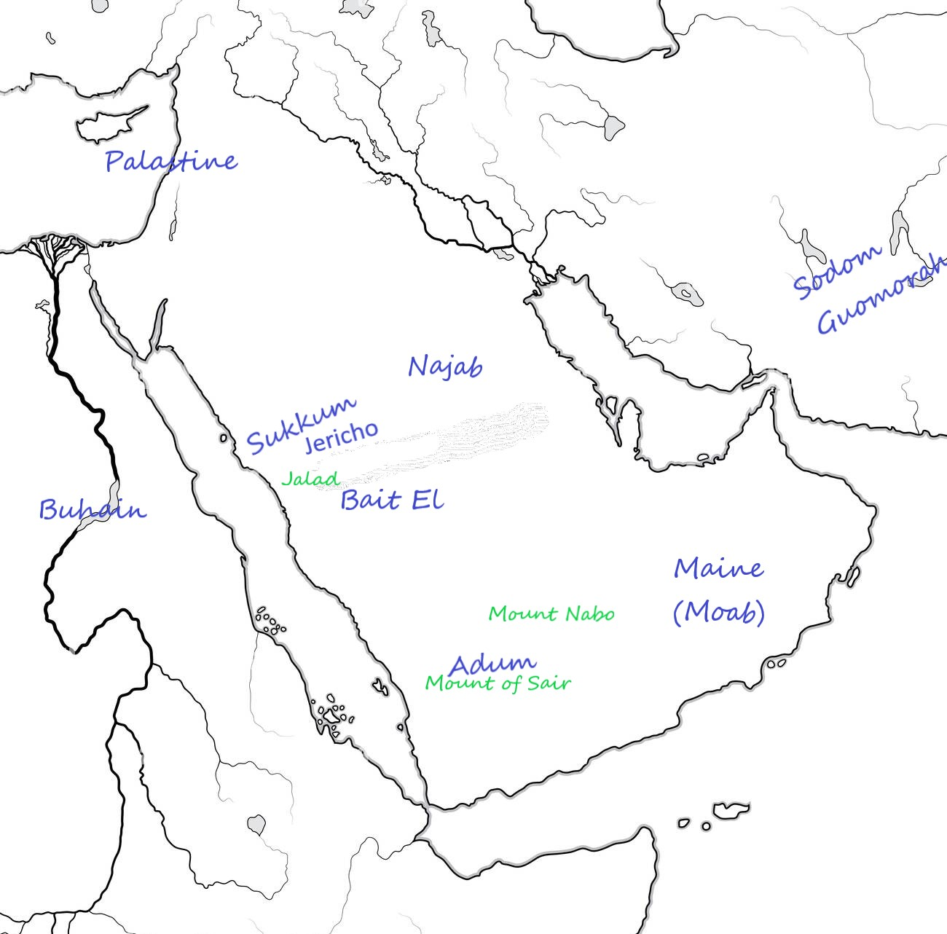
The Geography of Peninsula as I researched.

The Real geography of the regions described in the Torah
The Levites have added many fallacies to hide the truth. Among them, the biggest fallacy is the oak tree and the Jordan River, we are going to ignore such fallacy.
We will explore these areas in the present day, using the physical features of important and well-known areas described in the books of the Torah to examine the stories and events of the book, and using current-day archaeological research.

Saudi Arabia

Nations of the Area:
Hawi, Jezreeli, Eli, Ismaili, Jabai, Gibaoni, Maaki Yehuda, etc. are all names used for the children of Hazrat Ismail. Mostly for describing the lands of Saudi Arabia, they use the word Yehuda, as Ismael was the elder brother of Isaac. When we study the Hebrew bible, although they have covered the names and geography still we can recognize everything with the light of the Holy Prophet, SAW. After recovering the truth we also understand that descendants of Ismail remain supportive of Bani Israeel in all difficult times on the contrary they did what is known as snake's habit.
Canaanites or Jebusites: The original inhabitants of the Arabian Peninsula who were residents of the Arabian Peninsula before the arrival of Prophet Ibrahim (peace be upon him).

Geographical Names:
Nageb: = Nagd the center of Saudia as mentioned in Britannica:
"Najd, region, central Saudi Arabia, comprising a mainly rocky plateau sloping eastward from the mountains of the Hejaz".(“Najd | Desert, Bedouin, Oases | Britannica” n.d.)
Bethel Baitullah, as this is the real meaning of the word. And that is the only place that is named as the house of Allah according to all the nations and all the times. Which was the beginning point of creating the earth. Paran: Mountain range surrounding Makkah
Lows: = Mountains of Makkah to Taif, the area of Taif is still famous for the production of Almonds which are named in Arabic as lows, maybe this was the reason for naming the whole area as lows.
"TAIF: its widely cultivated almond trees, with their white flowers which add to the natural beauty of the area, are less well-known. Visitors arriving at the Makkah Province hill station set 1,879 meters up on the slopes of Saudi Arabia’s Sarawat Mountains, are often taken aback by the blanket of white almond orchards that greet them. ".(“Taif’s Almond Trees Add Color to Natural Beauty of ‘City of Roses’” 2020)
Gibeon:= Al-Jumum a city near Makkah, this word was used for the People of Makkah
Elim Makkah: The word is taken from El, meaning Lord, as Bait El is the house of Allah, as same Elim is the name for the city of Allah.
Hurmah is derived from Al-Khurmah, a city east of Mecca. It may also mean Makkah
Ai, = Arafat: Ground of Arafat
Mina: the place which is between Baitullah and Arafat
Hibron, Hirmon, = Hijaz province and meant in the story of Ibrahim as Madina. In the Whole book, this word is sometimes used for Madina and sometimes it's being used For Makkah.
the terebinths of Mamre, = The Palms of Madina, The fact is distorted again.
Shechem:= Sharam Yanbu: The old name of this city Yanbu was Sharm Yanbu, which was said as Shechem
"Location: 24.15323N 37.93766E Sharm Yanbu, located 15 km north of Yanbu (S. Arabia)":(“Sharm Yanbu Potential Ancient Port | Ancient Ports - Ports Antiques” 2017)
It is the area where Hazrat Ibrahim came. This area was once a sub-part of Najd province.
Jericho / the land of palm trees Madina: The name of the land of palm trees used for Jericho is the name of Medina itself. Jericho has sometimes been used as a sub-province of Edom and sometimes as a province itself. There are many physical features of the book inside Madinah, some of which are named below:
Tayyibah: another name used for Madinah
Jabal Salah: still exists in Madinah under the same name. It is located at a distance of about five hundred meters from the Prophet's Mosque towards the west.
Iro: The area between Jabal Ayr and Harrah in Madina
Arnon: Wadi Ranuna which is located near Bir Ares.
Birlahi Rowi / Ramat = Bir Ruha is located near the ground of Badr. It is in the Ruha valley, about which the Prophet (peace and blessings of Allah SWT be upon him) said that seventy prophets have passed through this valley. Hazrat Musa (peace be upon him) has also visited here. And Hazrat Isa (peace be upon him) will also pass through here and go for Umrah or Hajj.
Gilead: = Battlefield of Badar, between Makkah, Madina and Jeddah
Jaad: = Jadda: a city on red sea

Yemen, Oman, Iran, Afghanistan, Balochistan, Sindh, Punjab

Nations of the Area:
Descendents of Lot, mentioned as Moab:= Real name Maine, as they were living on the southeast of the peninsula, and their rule included the areas of Iran, Afganistan, and today's Pakistan. They were controlling both sides of the Water, thus they were named as People of Water, Although, the writer of the book tried to humiliate Lot and his daughters. The daughters of Lot married the Kinani people after returning from Sodom and Amorah.
"For many centuries, trade was the major source of wealth for the states that occupied the southern corner of the Arabian Peninsula."(“Yemen - Trade, Coffee, Spices | Britannica” n.d.)
Their country is mentioned as Basan. They are also called Rifaeem. They lived parallel to Sabayans:
"The Minaean kingdom (Maʿīn) lasted from the 4th to the 2nd century BCE and was predominantly a trading organization that, for the period, monopolized the trade routes. References to Maʿīn occur earlier in Sabaean texts",(“History of Arabia - Sabaean, Minaean Kingdoms | Britannica” n.d.)
descendants of Hazrat Aisou the elder son of Isaac Adomi:= Sabayon, earlier were the ruler of only the western part of Yemen, later on controlled over whole Yemen. The name of the state, in the beginning, was Adoum and later on, changed to Yarmouth.
"The Greek writer Eratosthenes (3rd century BCE) described “Eudaimon Arabia" (“History of Arabia - Sabaean, Minaean Kingdoms | Britannica” n.d.)
Sodom and Gomorrah: = Moin jo Daro and Harrapah:. The prophet Lot was sent to the east of Baitullah, Lot AS must have taken the way from Masqat to Gwadar and then to these cities which were at that time equal to Egypt.
Mufaat, present name Muscat: Archaeologists have found traces of vessels of the Harappan civilization here. I think it was from here that Hazrat Lut went to Moin Jodaro and Harappa. After their punishment, he returned to the Arabian Peninsula by the same route. His descendants ruled in present-day Oman and Yemen.
"A wide range of Indus artifacts have been found over the past forty years at many coastal and inland sites in the Oman peninsula, including utilitarian and ritual pottery, ornaments, seals, weights and, more recently, terracotta toys for children,"(“Oman | Harappa” n.d.)
Mount of Nabo: This mountain is actually "the mountain of Prophet Shoaib." Hazrat Shoaib was living on this mountain before Hazrat Musa or settled somewhere nearby. Apparently, after the destruction of the people of Madian, Hazrat Shoaib came to this area. On Musa coming back from Egypt Nabi Shoaib came to meet him and Then Musa went to meet him in his place. Musa used this peak as it was the highest peak of the Peninsula.
"Jabal a Nabi Shu'ayb is the highest peak on the Arabian Peninsula and is located in Sana’a Governorate. It lies at an elevation of 12,028 feet above sea level with a prominence of 10,912 feet. The etymology of the mountain is biblical. ".(“Highest Mountains In Yemen” 2017)
Another name for this mountain is Jabal Hadhur;
"Jabal An-Nabī Shuʿayb (Arabic: جَبَل ٱلنَّبِي شُعَيْب, lit. 'Mountain of the Prophet Shuaib'), also called Jabal Hadhur (Arabic: جَبَل حَضُوْر, romanized: Jabal Ḥaḍūr), is a mountain of the Harazi subregion of the Sarawat, located in Bani Matar District, Sanaa Governorate, Yemen. It is the highest mountain in the country and the Arabian Peninsula. It is one of the most prominent peaks in the world, and the third most prominent peak in the Middle East."(“About: Jabal An-Nabi Shu’ayb” n.d.)

Zoar: At present, it is a small town located in eastern Yemen, named Zogor. The name of the province is Hadhramout and the name of its district is Al-Zaliyah. This was mentioned on the way to Saddoom.
"ضغر هي إحدى قرى عزلة الضليعة بمديرية الضليعة التابعة لمحافظة حضرموت"،(“ضغر (الضليعة)” 2023)
Astarats: Apparently, it is the island of Tarot located in the present Qatif district of Saudi Arabia. As it is said, the name Tarot is derived from Istarat (an idol name that is abundant in Canaanite and Phoenician literature). An archeological palace has been discovered here. This area may have been a part of the Moabite kingdom in the beginning, later it entered the Dilmun kingdom, which was also called the Samaritan state.
"Tarout island was discovered in 5000 BC, which makes it one of the most ancient sites and oldest places inhabited by humans along the Arabian Peninsula. It was named after Ishtarut or Ashtaroot, which means God of Love and War. The Dilmun kingdom ruled the place in 3000 BC and played a significant role in the history of the region."(“Tarout Island: History, Location, Attractions, & Best Time To Visit” 2022)

Mount Seir and the country of Edom
Mount Seir is mentioned repeatedly in the book, Mount Seir was located in the area of the province of Edom and this area was given to Jacob's eldest son Esau. The mountain of Sha'ir still exists in the northwestern region of Yemen. This area is called Sada/Sadat or Sha'ir district in Ib province in present-day Yemen. His introduction in Geonames is mentioned as follows:
"Jabal ash Sha`r 3079 m 408341T MT mountain, Yemen YE » Ibb Governorate 23 » As Saddah District 1106, 14.09028, 44.36222"(“Jabal Ash Sha`r, Yemen” n.d.)
Wold Atlas describes as:
"The elevation of the mountain is 10,102 feet above sea level. It is located in As Saddah within the superior administrative division of Idd."(“Highest Mountains In Yemen” 2017)
Another research says:
"Ash Sha'ir District is a district of the Ibb Governorate, Yemen. As of 2003, the district had a population of 39,805 inhabitants. Type: District with 39,800 residents, Description: District of Ibb Governorate, Yemen, Categories: district of Yemen and locality, Location: Ibb Governorate, Yemen, Middle East, Asia"(“Ash Sha’ar District” n.d.)

In the country of Syria
Jarrar:
Jarar is the only Palestinian area where Hazrat Ibrahim and Hazrat Isaac also went because of famine.

The Real Story:

Ibrahim Migrated to Hijaz
In fact, Hazrat Ibrahim when he migrated from his house "Haran" in Today’s Turkey not in Iraq, came to Madina. He had come all along the Red Sea to Sukkum, today's Uanboo city of Saudia, and then moved toward Najad where he stopped in Madina, from where he went to Baitullah, Made Umrah and sacrificed at Mina.
"Abram passed through the land as far as the site of Shechem, at the terebinth of Moreh. The Canaanites were then in the land. יהוה appeared to Abram and said, “I will assign this land to your offspring.” And he built an altar there to יהוה who had appeared to him. From there he moved on to the hill country east of Bethel and pitched his tent, with Bethel on the west and Ai on the east; and he built there an altar to יהוה and invoked יהוה by name. Then Abram journeyed by stages toward the Negeb"(“Genesis” n.d.)
To complete the story we may add the last verse of the next chapter:
"And Abram moved his tent, and came to dwell at the terebinths of Mamre, which are in Hebron; and he built an altar there to יהוה". (“Genesis 13:14” n.d.)

Way of Lot:
After coming back from Egypt again all four(as this time Hajar was also with them as well) arrived at Baitullah. After the Umrah Allah SWT ordered Hazrat Lot to go to Sodom and Gomorrah which are found now as "Moin Jo Daro and Harraba" in Pakistan. He took the path through Masqat, and Gwadar all the way there. This place lies in the east of Baitullah.
"Lot looked about him and saw how well watered was the whole plain of the Jordan, all of it—this was before יהוה had destroyed Sodom and Gomorrah—to Zoar, like the garden of יהוה, like the land of Egypt. So Lot chose for himself the whole plain of the Jordan, and Lot journeyed eastward. Thus they parted from each other." (“Genesis 13:14” n.d.)

Promised Land For Ibrahim
If we see the verse mentioning the Promised Land. It shows us two points: 1. The land where Ibrahim was at that time was having distinguished features from other nearby lands. It can be in the whole world only in the Peninsula of Arabia. The other point is they won't be counted even if someone wants to. Jewish people always remain countable, and mostly being counted after a few years, since Musa's time. it can only be true if it was about all the descendants of Ibrahim.
" I will make your offspring as the dust of the earth, so that if one can count the dust of the earth, then your offspring too can be counted." (“Genesis 13:14” n.d.)

The Real Story of Abraham and his descendants according to the Torah
When Hazrat Ibrahim was ordered to migrate from Haran, he came with his wife and nephew Lut to Sikkim, which is located in the east near the present-day city of Yanbu near the Red Sea in Saudi Arabia and then from here toward Najab to Madina, and made an Umrah in Makkah. It was from here that they went to Egypt due to famine and there the famous incident of Hazrat Sarah took place and on the way back, Pharaoh tied Hazrat Hajra to the service of Hazrat Sarah. The first construction of Bait Allah was done by Hazrat Nuh (peace be upon him), whose remains were there in the time of Hazrat Ibrahim, and Hazrat Ibrahim was used to visit the area of Bait Allah to worship Allah. On their return from Egypt, after Sikkim, Hazrat Ibrahim, Hazrat Sarah, Hazrat Hajra, and Hazrat Lot again went to worship at Bait Allah, and from there, Hazrat Lot was ordered to go and preach in the eastern region. And through Muscat, near Gwadar, he came to the population of Sindh and Punjab at that time, which was called the civilization of the Indus River and was as lush and populated as Egypt. It was apparently called Sodom and Gomorrah at the time and is remembered today from the ruins of Moen Jo Daro and Harappa. After the destruction of the people of Sodom, Hazrat Lot came back and lived again in the Arabian Peninsula, but he settled his tribe in the area of present-day Oman. His descendants ruled the eastern part of Yemen, Oman, and other sides of Iran and Pakistan.
Hazrat Ibrahim went back to Medina from here. The first son of Hazrat Ibrahim (peace be upon him) who was born to Hazrat Hajra was Hazrat Ismail. Because the Torah is distorted and the original story is the same as the Hadith as well and according to the definition of the Torah, the first child is named after Allah. This was illustrated by ordering Hazrat Ismail to be slaughtered. And later it was a custom among the Israelites that the eldest child should be ransomed. And slaughtering the first fruits of animals etc. According to the order of Allah, Hazrat Ibrahim took Hazrat Ismail from his city Mamre(the palm-bearing land) of Madinah and brought him in front of the House of Allah. They tried to slaughter him in Mina and Allah gave Hazrat Ismail's ransom in the form of a ram. Later on, the Bani Israel imposed the command to pay the ransom of their firstborn at the same time Hazrat Ibrahim was the first time given the good news of their son Isaac from Sarah.
Then he gave the good news of Isaac again when the angels came to punish Sodom. At that time Sarah also heard. When Hazrat Ishaq was born, Hazrat Sarah started feeling bad about Hazrat Hajra and her son. Since Hazrat Hajra was the handmaiden of Hazrat Sarah and Sarah herself made him her husband's wife, Hazrat Sarah dealt harshly with Hazrat Hajrah, on which Hazrat Hajrah got angry and reached the area of Badr, which is called Bir Lahi Rui. Hadhrat Hajra went back to Madinah where an angel from Allah appeared to her and told her to go back. Hadhrat Sarah and Hajra quarreled and Hazrat Sarah asked Ibrahim for Hajra to be transferred somewhere else. Hazrat Hajra also wanted to stay away from Hazrat Sarah and the intention of Allah was also that Hazrat Ismail should settle in the city of Bait Allah. Therefore, before transferring to another place, Allah made Hazrat Ismail circumcised as his seal. Which was later practiced among the descendants of Hazrat Ismail. After circumcision Hazrat Ismail and them
The punishment came upon the nation of Sodom and today they exist in the form of Moen Jo Daro. Hazrat Lot returned from there and settled in the east of the Arabian Peninsula and married his daughters to the local people who were called Canaanites. The Jews found it necessary to abuse Hazrat Lot and his descendants here and a very ridiculous story they fabricated. The descendants of Hazrat Lot were called Moab or Main (Arabic name for water) because they lived by the seawater. Second, they had estates on both sides of the water and had complete control over the water. The generation of Hazrat Lut (peace be upon him) was the ruler of the southeastern coast of the Arabian Peninsula for a long time. For some time in the middle, they dominated the territories of the Edomites, but eventually, the Edomites occupied the entire Arabian Peninsula and especially the eastern region. People remember the Edomites as the nation of Sheba.
Hazrat Ibrahim made Hazrat Ismail stay near Baitullah in the mountains of Faran, then the Jarhmi tribe that settled here was a Canaanite tribe in the language of the book, and Hazrat Ismail married their girl. Then the descendants of Hazrat Ismail ruled Mecca, Hijaz, and Central Arabia especially.
Hazrat Ibrahim and Hazrat Sarah settled in Medina. Then Hazrat Ishaq went to his father's village Haran to get married and on the way stayed at Jarar where he received the good news about the territory of Palestine. Hazrat Ishaq returned and stayed in Medina. Hazrat Esau went to Makkah from here and married the daughter of Hazrat Ismail. From there they went to the country of Sha'ir in the southern region of Makkah and settled there and their descendants remained there. Hazrat Yaqoob also went to Haran to get married. He also got the good news in Jarar that his children will settle here. Hazrat Yaqub also returned and stayed in Medina. From here, Hazrat Yaqoob's children used to graze goats in the Yanbu area. In the same place, Hazrat Yusuf was thrown into a well and sold to the people of Yemen who used to go to Egypt to trade spices, etc.
It was here from Madinah that these people went to Egypt. When they escaped from Egypt with Hazrat Musa, they crossed the sea from Eritrea and entered the western region of Yemen, which was located along the border of the country of Edom, from here they returned to Makkah and camped in front of the Kaaba. Madinah was occupied by another nation. In Makkah, they remain the guest of the Ismailis here. Even at that time, everyone was allowed to enter the Kaaba. It was here that Hazrat Shoaib taught the children of Israel how to perform Hajj. And went back to his area. Then Hazrat Musa in his last age climbed the mountain of Hazrat Shuaib and looked around, then he saw the area in the south of Yemen to the sea and then to the north Medina the city of Palms from here. Hazrat Musa died in the same area.
From here, the Israelites started their conquests and conquered all the surrounding areas and conquered the area up to present-day Israel. Because of the fight with Saul, Hazrat Dawood came to Hijaz and became the ruler here in Makkah and ruled only in Hijaz for 7 years. It was here that he married a girl from the descendants of Hazrat Ismail and her descendants were probably the parents of Hazrat Amina the mother of prophet SAW, as she was from the Najjar family. (The family of Hazrat Esa, Jesus Christ, was also named as Najjar. Maybe the Najjar family was from Hazrat Dawood's family, thus Hazrat Esa and the prophet SAW both are Dawood's sons from the maternal side.) Then Hazrat Dawood occupied Israel for the remaining thirty-three years. And established the throne in Israel and ruled the area up to Makkah. After Hazrat Dawood, Hazrat Sulaiman (AS) built a temple in Jerusalem. From there, they came to Kaaba to perform Hajj. At the same time, the incident of the bird "Hudhud" happened and he came to know about the Queen of Saba, then the Queen of Saba converted to Islam. When Jeroboam and Bani Israel rebelled against the son of Hazrat Sulaiman, they came and settled here in Hijaz. Then Jeroboam fixed the Hajj and all the other terms in Jerusalem. After which destruction came on Bani Israel for the second time.

Results:
In the Torah and related books, the original geography and descendants of Prophet Ishmael and Esau were hidden so that others could not get acquainted with the true story and prophecies of the Torah. But this veil has turned the Torah itself into an incomprehensible mess. Unraveling this context is crucial to understanding the story of the Torah.
Two main characters change the Torah: 1. Levi, No. 2. Jeroboam.
Levites were forbidden to own property. Their religious responsibility was only to guide the people and protect the religious affairs. However, the Levites started their role as regular property dealers. They had not only claimed the right to create properties for themselves, on the contrary, expel the religion out of the Torah and fabricated it as the book to occupy the land.
Jeroboam was actually a rebel. He was in exile during the reign of Sulaiman. After the death of Hazrat Sulaiman, he provoked the Israelites in the matter of taxes and turned them against the Rehoboam the son of Hazrat Sulaiman. Rehoboam along with his tribe came to Hijaz to save their lives. The Israelites made Jeroboam their king. Jeroboam was afraid of losing his kingdom in case they continued to go to Hijaz to perform Hajj, so maybe love for the family of David would wake up in their hearts again, and they make him king again. Thus he changed the Method of Hajj. And named the geographical symbols in Jerusalem. And created their own Baitullah, Arafat, etc. also a new way to perform Hajj and named it Eid Mazal.
Hazrat Ibrahim came to Hijaz. Until Hazrat Yaqub, the whole family stayed in Madinah and went to Egypt with Hazrat Yusuf from there. Bani Israel escaped from Pharaoh and lived in Hijaz. Here on Mount Nabi Shuaib, which is the highest mountain of the peninsula, and which is called Mount Nabu in the Torah. Hazrat Musa climbed it in the last days of his life and saw the entire Arabian Peninsula.
In the book, Yanbu is called Sikkim, Najd is Najab, Medina is Mamre, Jericho and Tayyaba. While Mecca is called Elim, Gibeon, and Harmon. Bait Allah is called Bait El and Arafat is called Ai. Hijaz is called Hebron and Harmon. In addition, the Hejaz region has been repeatedly referred to as the Judean region. Judah is a metaphor for Hazrat Ishmael because just as Hazrat Ismail was older than Isaac, Judah was the eldest brother among the Israelites. Eastern Yemen and Oman have been called Moab and western Yemen has been called Edom.

Recommendations
Archaeologists are requested to recheck the historical evidence in these places according to this research. More scholars are requested to do more research on Torah and geography. Also, my special recommendation is for the Saudi government to research this approach with friends in archaeology. Also, people interested in this subject should be supported.

Notes of the article:

“Sefaria: A Living Library of Jewish Texts Online,” accessed October 18, 2023, https://www.sefaria.org/texts. Genesis Chapter 13 v 14-16
“Sefaria: A Living Library of Jewish Texts Online,” accessed October 25, 2023, https://www.sefaria.org/texts/.genesis ch17 v21
(موسیٰ, کتاب پیدائش ۔ عہدنامہ قدیم ۱۹۷۹)
“Sefaria: A Living Library of Jewish Texts Online,” accessed October 25, 2023, https://www.sefaria.org/texts/.Genesis ch 21 v9-12
“Sefaria: A Living Library of Jewish Texts Online,” accessed October 25, 2023, https://www.sefaria.org/texts/.Genesis Ch: 25 v30-33
“Sefaria.”Genesis: Ch: 10 V: 19
Dr David E. Graves, “Biblical Archaeology: Map 13,” Biblical Archaeology (blog), June 11, 2016, https://biblicalarchaeologygraves.blogspot.com/2016/06/map-13.html.
“Exodus 13,” accessed November 24, 2023, https://www.sefaria.org/Exodus.13. :v 17
“Buhen: An Egyptian Fortress in Nubia,” Egypt Exploration Society, August 30, 2017, https://www.ees.ac.uk/buhen-an-egyptian-fortress-in-nubia.
“Nubian Desert | Sahara, Sand Dunes, Erosion | Britannica,” November 6, 2023, https://www.britannica.com/place/Nubian-Desert.
“Tanakh | Sefaria,” accessed November 24, 2023, https://www.sefaria.org/texts/Tanakh.Numbers:Ch: 21, V: 4
“Exodus Route from Egypt, Red Sea Crossing Site, Mt. Sinai Location in Arabia | HolyLandSite.Com,” holylandsite, accessed November 24, 2023, https://www.holylandsite.com/exodus-redsea-sinai.
Israel Drazin, “‘Moses Did Not Write the Entire Torah.,’” accessed November 21, 2023, https://blogs.timesofisrael.com/moses-did-not-write-the-entire-torah/.
[البقرة: 78]
[البقرة: 79]
“Tanakh | Sefaria,” accessed November 24, 2023, https://www.sefaria.org/texts/Tanakh. Deuteronomy.18.1-5
“Leviticus 25:35,” accessed November 24, 2023, https://www.sefaria.org/Leviticus.25.35?lang=bi&aliyot=0.
“Tanakh | Sefaria.”Genesis Ch: 9 V26-27
“I Kings 12:28-33,” accessed November 25, 2023, https://www.sefaria.org/I_Kings.12.28-33?lang=bi.
“Jeremiah,” accessed November 24, 2023, https://www.sefaria.org/Jeremiah.ch: 48, V13
[النساء: 53-54]
“Najd | Desert, Bedouin, Oases | Britannica,” accessed November 24, 2023, https://www.britannica.com/place/Najd.
“Taif’s Almond Trees Add Color to Natural Beauty of ‘City of Roses,’” Arab News, March 2, 2020, https://arab.news/4t7ss.
“Sharm Yanbu Potential Ancient Port | Ancient Ports - Ports Antiques,” February 10, 2017, https://www.ancientportsantiques.com/a-few-ports/sharm-yanbu/.
“Yemen - Trade, Coffee, Spices | Britannica,” accessed November 25, 2023, https://www.britannica.com/place/Yemen/Trade.
“History of Arabia - Sabaean, Minaean Kingdoms | Britannica,” accessed November 25, 2023, https://www.britannica.com/topic/history-of-Arabia-31558/Sabaean-and-Minaean-kingdoms.
“History of Arabia - Sabaean, Minaean Kingdoms | Britannica.”
“Oman | Harappa,” accessed November 25, 2023, https://www.harappa.com/category/place/oman.
“Highest Mountains In Yemen,” WorldAtlas, April 25, 2017, https://www.worldatlas.com/articles/highest-mountains-in-yemen.html.
“About: Jabal An-Nabi Shu’ayb,” accessed November 20, 2023, https://dbpedia.org/page/Jabal_An-Nabi_Shu'ayb.
“ضغر (الضليعة),” in ويكيبيديا, September 15, 2023, https://ar.wikipedia.org/w/index.php?title=%D8%B6%D8%BA%D8%B1_(%D8%A7%D9%84%D8%B6%D9%84%D9%8A%D8%B9%D8%A9)&oldid=64581796.
“Tarout Island: History, Location, Attractions, & Best Time To Visit,” Zamzam Blogs, August 30, 2022, https://zamzam.com/blog/tarout-island/.
“Jabal Ash Sha`r, Yemen,” accessed November 18, 2023, https://www.geonames.org/408341/jabal-ash-sha%60r.html.
“Highest Mountains In Yemen.”
“Ash Sha’ar District,” Mapcarta, accessed November 18, 2023, https://mapcarta.com/26226934.
“Tanakh | Sefaria.”Genesis Ch 12 V: 6-9
“Tanakh | Sefaria.”Genesis Ch 13 V 18
“Genesis,” accessed November 16, 2023, https://www.sefaria.org/Genesis. ch 13 V:10-11
“Genesis.” ch 13 V:14-16 Bibliography: Joseph. n.d. Hebrew Literature . Barclay. MOSA. 1979. AHBAR (EHAD NAMA QADEEM). LAHOOR: BIBLE SOCIETY. “About: Jabal An-Nabi Shu’ayb.” Accessed November 20, 2023. https://dbpedia.org/page/Jabal_An-Nabi_Shu'ayb. Arab News. “Taif’s Almond Trees Add Color to Natural Beauty of ‘City of Roses,’” March 2, 2020. https://arab.news/4t7ss. Drazin, Israel. “‘Moses Did Not Write the Entire Torah.’” Accessed November 21, 2023. https://blogs.timesofisrael.com/moses-did-not-write-the-entire-torah/. Egypt Exploration Society. “Buhen: An Egyptian Fortress in Nubia,” August 30, 2017. https://www.ees.ac.uk/buhen-an-egyptian-fortress-in-nubia. “Exodus 13.” Accessed November 24, 2023. https://www.sefaria.org/Exodus.13. “Genesis.” Accessed November 16, 2023. https://www.sefaria.org/Genesis. Graves, Dr David E. “Biblical Archaeology: Map 13.” Biblical Archaeology (blog), June 11, 2016. https://biblicalarchaeologygraves.blogspot.com/2016/06/map-13.html. “History of Arabia - Sabaean, Minaean Kingdoms | Britannica.” Accessed November 25, 2023. https://www.britannica.com/topic/history-of-Arabia-31558/Sabaean-and-Minaean-kingdoms. holylandsite. “Exodus Route from Egypt, Red Sea Crossing Site, Mt. Sinai Location in Arabia | HolyLandSite.Com.” Accessed November 24, 2023. https://www.holylandsite.com/exodus-redsea-sinai. “I Kings 12:28-33.” Accessed November 25, 2023. https://www.sefaria.org/I_Kings.12.28-33?lang=bi. “Jabal Ash Sha`r, Yemen.” Accessed November 18, 2023. https://www.geonames.org/408341/jabal-ash-sha%60r.html. “Jeremiah.” Accessed November 24, 2023. https://www.sefaria.org/Jeremiah. “Leviticus 25:35.” Accessed November 24, 2023. https://www.sefaria.org/Leviticus.25.35?lang=bi&aliyot=0. Mapcarta. “Ash Sha’ar District.” Accessed November 18, 2023. https://mapcarta.com/26226934. “Najd | Desert, Bedouin, Oases | Britannica.” Accessed November 24, 2023. https://www.britannica.com/place/Najd. “Nubian Desert | Sahara, Sand Dunes, Erosion | Britannica,” November 6, 2023. https://www.britannica.com/place/Nubian-Desert. “Oman | Harappa.” Accessed November 25, 2023. https://www.harappa.com/category/place/oman. “Sefaria: A Living Library of Jewish Texts Online.” Accessed October 18, 2023. https://www.sefaria.org/texts. “Sefaria: A Living Library of Jewish Texts Online.” Accessed October 25, 2023. https://www.sefaria.org/texts/. “Sefaria: A Living Library of Jewish Texts Online.” Accessed October 25, 2023. https://www.sefaria.org/texts/. “Sefaria: A Living Library of Jewish Texts Online.” Accessed October 25, 2023. https://www.sefaria.org/texts/. “Sharm Yanbu Potential Ancient Port | Ancient Ports - Ports Antiques,” February 10, 2017. https://www.ancientportsantiques.com/a-few-ports/sharm-yanbu/. “Tanakh | Sefaria.” Accessed November 24, 2023. https://www.sefaria.org/texts/Tanakh. “Tanakh | Sefaria.” Accessed November 24, 2023. https://www.sefaria.org/texts/Tanakh. WorldAtlas. “Highest Mountains In Yemen,” April 25, 2017. https://www.worldatlas.com/articles/highest-mountains-in-yemen.html. “Yemen - Trade, Coffee, Spices | Britannica.” Accessed November 25, 2023. https://www.britannica.com/place/Yemen/Trade. Zamzam Blogs. “Tarout Island: History, Location, Attractions, & Best Time To Visit,” August 30, 2022. https://zamzam.com/blog/tarout-island/. “ضغر (الضليعة).” In ويكيبيديا, September 15, 2023. https://ar.wikipedia.org/w/index.php?title=%D8%B6%D8%BA%D8%B1_(%D8%A7%D9%84%D8%B6%D9%84%D9%8A%D8%B9%D8%A9)&oldid=64581796. This work is licensed under a Creative Commons Attribution 4.0 International License.

